SESSS Championship Show 2026 – Judge Kate Keely (Alhambian/Shipden)

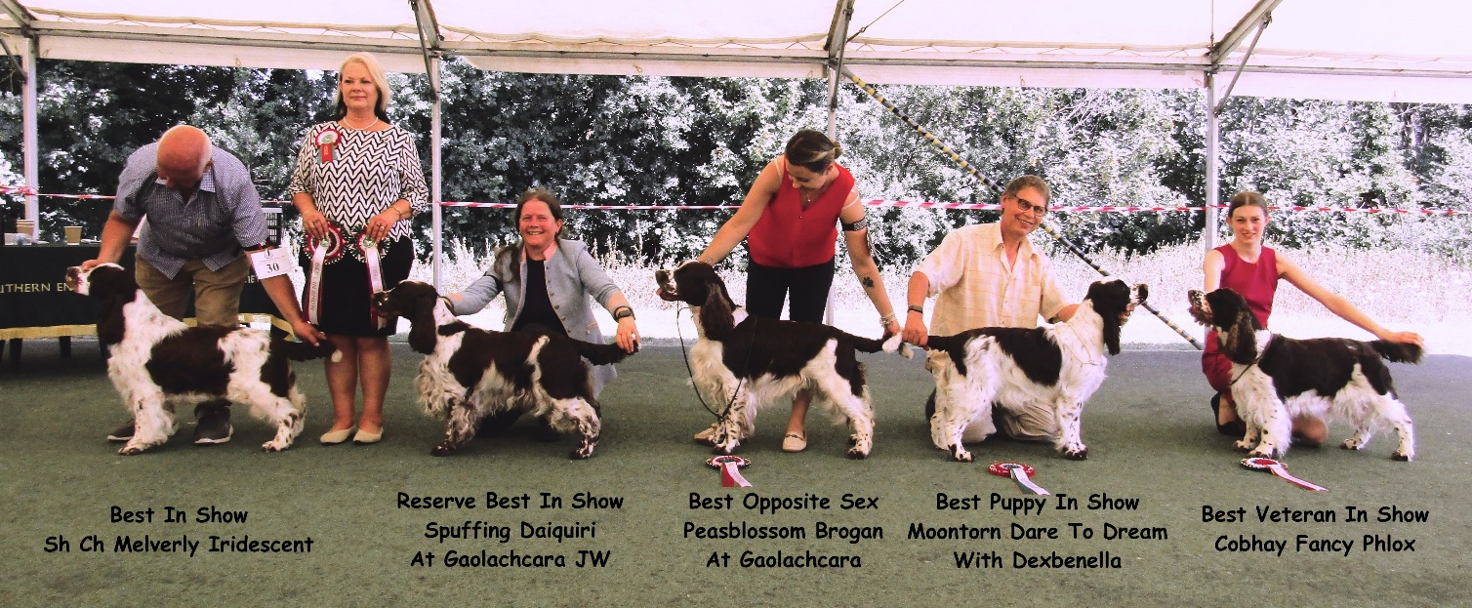

Best In Show: Sh Ch Melverly Iridescent (Mr R J Smith)
Res BIS: Spuffing Daiquiri at Gaolachcara JW (Ms Stevenson)
BOS: Peasblossom Brogan at Gaolachcara (Ms Stevenson)
Dog CC: Peasblossom Brogan at Gaolachcara (Ms Stevenson)
Res Dog CC: Greg De Les Tres Llacunes (Imp ESP) (Mr C & Mrs J Gledhill)
Bitch CC: Sh Ch Melverly Iridescent (Mr R J Smith)
Res Bitch CC: Spuffing Daiquiri at Gaolachcara JW (Ms Stevenson)
Best Puppy: Moontorn Dare To Dream With Dexbenella (Mr S P & Mrs W M Walker)
Res Best Puppy: Eastriding Gold Dust (Mrs K Jenkinson)
Best Veteran: Cobhay Fancy Phlox (Mrs J, Mrs D & Miss P Williams & Toublic)
Best B&W: Forgespring Nobody’s Fool at Blissenbea (Mrs M Proctor)

Minor Puppy Dog. 1 Entry Abs: 0
1st Peasblossom Fidelio At Swiftflush (Mr C & Mrs J Gledhill)

Puppy Dog. No Entries

Junior Dog. 1 Entry Abs: 0
1st Favours Joy Ride to Baudelaire (Imp Swe) (Miss H Field-Enticott)

Yearling Dog. 1 Entry Abs: 1

Novice Dog. No Entries

Graduate Dog. 5 Entries Abs: 0
1st Eastriding Royal Gold (Mrs K Jenkinson)
2nd Kingsheath Sun Dance (Mrs J Fitchett)
3rd Forgespring Tomfoolery (Mrs C E & Mr P J Turrell)
4th Petranella Strike It Lucky (Ms C P Savell)
VHC Meonstoke Woodpecker at Grosbreuil (Mrs D West)

Post Graduate Dog. 2 Entries Abs: 0
1st Beresford Stand At Ease JW (Mrs T E Topliss)
2nd Daenerys Playing With Fire (Mrs K Allery)

Mid Limit Dog. 2 Entries Abs: 0
1st Peasblossom Brogan at Gaolachcara (Ms Stevenson)
2nd Kingsheath Sun Dance (Mrs J Fitchett)

Limit Dog. 2 Entries Abs: 0
1st More Than Amazing Wanna Be A Gangster at Spuffing JW (Imp Bel) (Mrs J Weyman)
2nd Beresford Stand N' Stare JW (Mrs T E Topliss)

Open Dog. 5 Entries Abs: 1
1st Greg De Les Tres Llacunes (Imp ESP) (Mr C & Mrs J Gledhill)
2nd Meltarose Midshipman (Mrs E Rowlinson)
3rd Beresford On My Way With Acregate (Miss J J Tracz)
4th Favours Joy Ride to Baudelaire (Imp Swe) (Miss H Field-Enticott)

Veteran Dog. No Entries

Special Beginners Dog 1 Entries Abs: 0
1st Kingsheath Sun Dance (Mrs J Fitchett)

President Special Open Stakes Dog: No Entries

Minor Puppy Bitch. 1 Entries Abs: 0
1st Moontorn Dare To Dream With Dexbenella (Mr S P & Mrs W M Walker)

Puppy Bitch. 1 Entries Abs: 0
1st Eastriding Gold Dust (Mrs K Jenkinson)

Junior Bitch. 1 Entries Abs: 0
1st Petranella Strike A Pose (Ms C P Savell)

Yearling Bitch. 5 Entries Abs: 3
1st Spuffing Daiquiri at Gaolachcara JW (Ms Stevenson)
2nd Eastriding Royal Style (Mrs K Jenkinson)

Novice Bitch. 3 Entries Abs: 1
1st Petranella Strike A Pose (Ms C P Savell)
2nd Baudelaire Harvest Sun (Miss H Field-Enticott)

Graduate Bitch. 7 Entries Abs: 0
1st Spuffing Bellini JW (Mrs J Weyman)
2nd Meonstoke Wild Thyme Ir Jch (Mrs K C Taubman)
3rd Forgespring Nobody’s Fool at Blissenbea (Mrs M Proctor)
4th Meonstoke Wild Cherry At Harvancourt (Miss T Turvey &Mrs J Murray)
5th Petranella Strike A Pose (Ms C P Savell)

Post Graduate Bitch. 4 Entries Abs: 4

Mid Limit Bitch. 5 Entries Abs: 2
1st Beresford Stand On Ceremony JW (Mrs T E Topliss)
2nd Spuffing Prosecco (Mrs J Weyman)
3rd Petranella Perfick Bliss At Blissenbea (Mrs M Proctor)

Limit Bitch. 7 Entries Abs: 3
1st Dexbenella Double Take (Mr S P & Mrs W M Walker)
2nd Barecho Fame Queen At Eastriding (Mrs K Jenkinson)
3rd Seaspring Windcatcher At Chipewyan (Mrs P Strover)
4th Crackerjanne Cassiopeia (Mrs V K Pattison)

Open Bitch. 5 Entries Abs: 1
1st Sh Ch Melverly Iridescent (Mr R J Smith)
2nd Ir Sh Ch Meltarose Madeleine at Meonstoke (Mrs K C Taubman)
3rd Seaspring Windcatcher At Chipewyan (Mrs P Strover)
4th Baudelaire Harvest Sun (Miss H Field-Enticott)

Veteran Bitch. 2 Entries Abs: 1
1st Cobhay Fancy Phlox (Mrs J, Mrs D & Miss P Williams & Toublic)

Special Beginners Bitch 3 Entries Abs: 0
1st Meonstoke Wild Cherry At Harvancourt (Miss T Turvey &Mrs J Murray)
2nd Forgespring Foolproof (Mrs V K Pattison)
3rd Forgespring Fool Me Once (Mrs E L Stephens)

President Special Open Stakes Bitch: 4 Entries Abs 3
1st Crackerjanne Cassiopeia (Mrs V K Pattison)

